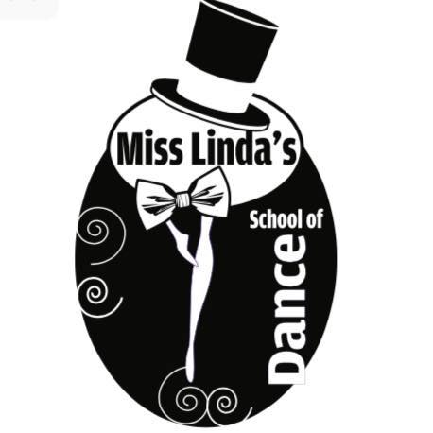

2025-2026 Handbook

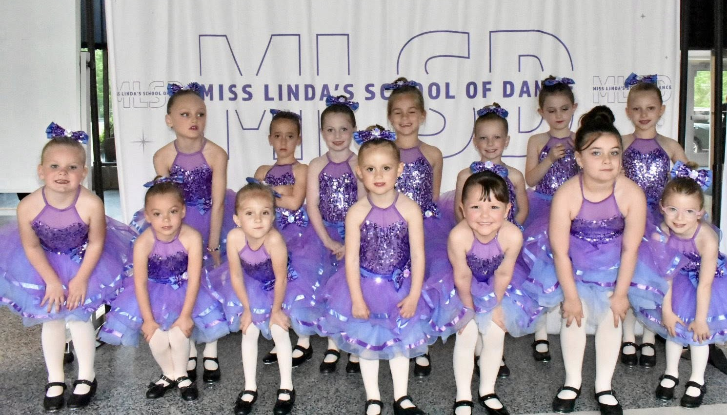

Miss Linda’s School of Dance

Linda Hodges Damatin
misslindassschoolofdance@yahoo.com

September 2025
Welcome to Season 32 of Miss Linda’s School of Dance. We hope your summer has been a restful and relaxing one. We are looking forward to a great year of fun and exciting dance classes. We have lots of new things in store for this year’s classes and especially this year’s show which will be held on Saturday May 30th at Fontbonne High School.
Please read this handbook and ask either Miss Linda or one of the teachers if you have any questions. After thirty-two successful years we have learned a great deal about how the studio should be operated. For this reason, we ask for your cooperation and support. Please carefully read the sections regarding uniforms and shoes as some classes have changed this year. If you have any questions, please ask.
Classes are held at the Michael J. Perkins Post on O and East Fourth Street in South Boston and 771 Adams Street in Dorchester (above Joe Glynn cleaners). The studios open for classes on Monday, September 8th. We have found that the best form of communication is through email. Please make sure we have your correct email on file. If you have any questions, our studio email is misslindasschoolofdance@yahoo.com We look forward to a great dance year!

History
Miss Linda’s School of Dance first opened in the fall of 1994. The 1st dance recital was held on June 6, 1995, and included about 40 students in 18 different numbers. On June 8, 2024, we held our 30th recital which consisted of 3 shows and 300 dancers!
In September 2025 we will mark our 32nd season. Over the past several years the studio has evolved to meet the needs of the students and families in the communities in which we live. We have expanded our classes and now offer a new component to our program, the competitive edge. We are proud to offer our students an opportunity to study a wide range of dance and experience the competition side of the industry. We listened to our customers and designed a curriculum that best meets everyone’s needs. As we enter our fall season, we have 59 dancers on our competition teams who are looking forward to competing again this year.
In September 2014 we opened a second location in Dorchester. This September we will celebrate our 12th Anniversary and will continue to be located in the heart of Adams Village at 771 Adams Street. As this location continues to grow, we will be offering a wider range of classes.

Studio Staff

Owner / Teacher: Linda Hodges Damatin
Recital Coordinators: Colleen O’Dwyer Cummings, Stefanie Russo
Teachers: Victoria Bemis, Julia Biagiotti, Ashley Carpenter, Julia Damatin, Liley Damatin, Sarah Evans,
Pamela Evans, Jocelyn Fields, Michelle Hynes, Caroline Larkin, Michelle Ratican, Jayla Robinson,
Caroline Ream, Stefanie Russo, Elaina Ventre, Becca Waning, Shannon Zarnoch
Ballet Teacher: Peggy Ryan
Student Teachers: Hailey Alexander, Callie Barrett, Brydie Cikacz, Stella Cote,
Ava McLaughlin, Catherine Vlastos
T-Shirt/Program Design: Ann Marie Norton

Policies and Procedures

Calendar
- Miss Linda’s School of Dance is open from September until our recital. The studio is closed during school vacations. Every Monday you will receive a weekly newsletter giving studio highlights and updates.

Attendance
- It is very important that attendance be consistent. If a student misses more than 4 lessons, they will be asked to leave the studio. It is very difficult to re-teach the same routines repeatedly due to the absence of many children. Attendance will be taken at the beginning of each class.

Snow Days
- We have changed our policy regarding inclement weather and will no longer be following the Boston Public School policy. Due to inclement weather, a message will be posted on our Facebook page and website. Please check for updates before you come to class.
Communication
- All communication will be done through email. You will receive billing, newsletters, class changes & cancellations via email. Please be sure we have your current email address on file.

Dance Attire
Students are expected to come to every dance class with their correct shoes and uniform.

South Boston Studio
- Mon 9:00 & 2:45, Tues 2:45 & 3:45, Wed 4:30, Thurs 3:00, Sat 9:00 & 9:45
  - Black Leotard with pink or tan tights (optional black or pink dance skirt)
  - White tap shoes, pink ballet slippers
- Mon 3:45 downstairs, Tues 4:45, Saturday 10:30 & 11:30
  - Black Leotard with pink or tan tights (optional black dance shorts or black or pink dance skirt)
  - Black Mary Jane tap shoes, pink ballet slippers
- Mon 6:00
  - Black leotard OR black tank with black dance shorts or black leggings
  - Black Mary Jane tap shoes OR black Capezio tie taps, tan jazz shoes
- Tues 5:30 / Senior Dance
  - Black leotard or black tank top with black dance shorts or black leggings
  - Black Capezio tie taps, tan jazz shoes
- Contemporary – Mon 6:00 p.m.
  - Black leotard OR tank with black dance shorts or leggings
  - Foot undies
- Hip Hop – Thurs 3:45
  - Shorts or sweats with a t-shirt
  - Sneakers are mandatory

Dorchester Studio
- Mon 3:00 & 3:45, Tues 9:00 & 3:15, Thurs 3:00 & 4:00
  - Black Leotard with pink or tan tights (optional black or pink dance skirt)
  - White tap shoes, pink ballet slippers
- Thurs 5:00
  - Black Leotard with pink or tan tights (optional black dance shorts or black or pink dance skirt)
  - Black Mary Jane tap shoes, pink ballet slippers
- Wed 5:00
  - Black leotard with pink or tan tights OR black tank with black dance shorts or black leggings
  - Black Mary Jane tap shoes, tan jazz shoes
- Tues 4:15
  - Black leotard or black tank top with black dance shorts or black leggings
  - Black Capezio tie taps, tan jazz shoes
- Contemporary – Tues 6:30
  - Black leotard OR tank with black dance shorts or leggings
  - Foot undies
- Hip Hop – Mon 4:45, Tues 5:15
  - Shorts or sweats with a t-shirt
  - Sneakers are mandatory

Boys
- Black shorts or sweatpants, black or white t-shirt
- Black tap shoes, black jazz shoes

Adult Dance
- Black tap shoes, black jazz shoes

2026 Recital Information

Miss Linda’s School of Dance annual recital will be held at Fontbonne High School. In addition to the beautiful (air conditioned) auditorium and professional stage, there is a state-of-the-art sound system and an excellent space for students who are waiting to go on stage. Parking is free.

Recital Package Fee: Each family will be charged a $130.00 recital fee if you have one child at the studio and $160.00 recital fee if you have multiple children. This will include 2 tickets to our annual dance recital, video of your students dance recital, 2026 recital t-shirt and the $30 rehearsal fee (please note: families with more than one dancer will also be charged an additional $20.00 per dancer for their recital t-shirt).

An informational packet with specifics about Ticket Day, Rehearsal and Recital policies as well as video information, picture day information and summer camp will be sent home before April vacation.
- Dance Recital: Saturday May 30th, we run multiple recitals on May 30th, families will receive assignments in January
- Mandatory Rehearsal: Tuesday May 26th 4:00 – 8:00, Wednesday May 27th 4:00 – 8:00 families will receive assignments in January
- Tickets on sale: In April we will send out a google doc which will allow you to order additional recital tickets. The cost per ticket is $20.00 each.

Parent Committee

Purpose
- Communicate with parents in each class during recital time so that everyone understands all the studio’s policies.
- There are many young students, especially as the studio grows, and there are many new families. By having representatives for each class, it ensures each parent has someone to ask questions of during the busiest time of the year - recital time.
- Committee Members are involved in helping back-stage during rehearsal and at the recital. There are simply too many students to effectively manage backstage. This also gives younger students a familiar face to stay with while waiting to go on stage. A system is in place so that every parent will have the opportunity to see their child on stage from the audience.

Involvement
- Two representatives per class are needed who are available for dress rehearsal and dance recital and able to attend one Parent Committee meeting (date to be announced).

For parents who fully commit to helping, there are two perks:
- advance ticket purchase for additional recital tickets
- waiver of the advanced registration fee

Awards

2025 Award Recipients: Madelyn Barrett, Gemma Demello, Deirdre Guerard

Each year an award is given to at least two students who have put forth their best effort all year, have demonstrated spirit and enthusiasm in class, and have been faithful, cooperative and a pleasure to have in class. The students receive a small gift as well as a one-year scholarship of free class tuition. Award recipients are students who have danced for several years.
Fees and Payments

Class Fees
- We have now moved to an online system called the Studio Director. Payments will be charged automatically on the 10th of every month through the debit or credit card that is kept on file. Families will be able to log in to the parent portal for class and billing information. Please note: Miss Linda has the right to cancel 2 classes throughout the year for inclement weather or sickness without offering make up classes. Class fees are based on a yearly amount divided by 9 monthly installments.

Fees are as follows:
- 60 minute class $75 per month
- 45 minute class $65 per month

Please note: Rates are based upon a monthly installment. Payment is the same each month regardless of absence from class.

Annual Fees

Registration Fee: $30 per family

Recital Package: $130.00 per family with one student and $160.00 per family with multiple
children (charged on May 10th)

Costume Fees: $90.00 per student

Other Fee: $15 added to your account if payment is not made by 15th of each month.

Costumes

Each class will perform two dances in our annual recital. Students will receive one costume for the recital, and it will be worn for both dances. Costumes must be ordered in January to ensure delivery for the recital. The cost for the one costume is $90.00. Hip Hop Students will not be charged for costumes as they will be assigned a costume to purchase on their own. Payments will be charged to your account in January. See information on the fees page for more details. Students are measured before the winter break in December.

The costume payment will also be charged to your account as part of your January class fee (on January 10th). Students who take more than one class will be charged an additional fee for each costume.

Please Note: Payments are non-refundable.

Studio Calendar 2025-2026
Monday, September 9th – Studio Open
Monday, October 13th – Closed for Columbus Day
Tuesday November 11th – Open on Veterans Day
Wednesday, November 26th through Saturday, November 29th – Closed for Thanksgiving break
Monday, December 1st – Studios reopen
Monday, December 22nd through Saturday January 3rd – Closed for Christmas break
Monday, January 5th – Studios reopen
Monday, January 19th – Closed for Martin Luther King Day
Monday, February 16th through Saturday, February 21st – Closed for February break
Monday, February 23rd – Studios reopen
Tuesday March 17th – Open on Saint Patrick’s Day
Monday, April 20th through Saturday, April 25th – Closed for April break
Monday, April 27th – Studios reopen
Saturday, May 23rd through Monday, May 25th – Closed for Memorial Day Weekend
Tuesday May 26th – Rehearsal Fontbonne High School
Wednesday May 27th – Rehearsal Fontbonne High School
Saturday May 30th – Recitals Fontbonne High School

Contract

I have read the policies and procedures for Miss Linda’s School of Dance. I understand and will abide by the rules set forth in the Handbook.

I have logged in to my parent portal and ensured that the information for myself and my child(ren) is accurate.

Child/Children’s Names: ____________________________________________________

Parent’s Name (Please Print): ____________________________________________________

Parent’s Signature: ____________________________________________________

Email Address ________________________________________ Cell # __________________

Upon receipt of the handbook – please electronically sign this form
or print, sign, scan and email to misslindasschoolofdance@yahoo.com

